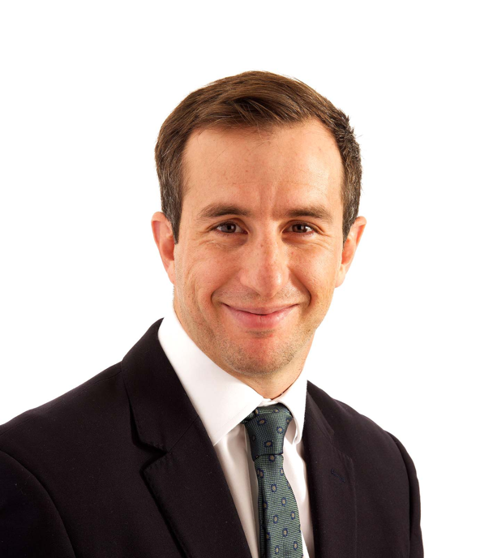
Santiago Graffigna
Santiago is a dual-qualified Solicitor (England & Wales) and abogado (Argentina). He’s a Legal Director at the firm and is based in London. His practice covers large and complex arbitrations across various sectors and regions, with a particular focus on energy, construction, and mining.
He is a member of the International Bar Association, the Society of Construction Law and the Dispute Resolution Board Foundation. He is also a young member of the ICCA, LCIA, ICDR and the Argentine Lawyers Association of New York. He is also a visiting lecturer at Universidad Austral in Buenos Aires in the Construction LLM.
Santiago speaks English and Spanish.

Santiago’s experience includes:
- Representing the contractors in an ICC arbitration arising from a road project in East Africa.
- Advising a major global contractor in relation to a dispute arising from the termination of a FIDIC contract to build a highway in a mountainous region in Central Europe.
- Acting as Tribunal Secretary in an HKIAC case related to the construction of a power plant in Southeast Asia.
- Representing the contractors in two ICC arbitrations arising from changes and breaches of contract in respect of a central processing facility and associated pipeline required to develop a gas field concession in North Africa.
- Representing the charterers in an international arbitration claim arising from demurrage and frustration of contract.
- Representing a British provider of plant and infrastructure in a TCC claim against Network Rail arising from major upgrades to rail equipment.
- Advising a Swiss national on a dispute with his former fellow members of an LLP constituted under English Law.
- Part of the team advising Peru in three ICSID arbitrations arising from alleged delays in providing necessary permits to build hydroelectric power plants.
- Part of the team representing a Spanish company in an ICSID claim against Colombia relating to the regulatory framework for electricity supply.
- Part of the team representing a major Asian national energy company in an ICC arbitration relating to issues of force majeure under a gas transportation agreement in Southeast Asia.
- Part of the team representing the Panamanian parent company of a Canadian junior mining in a claim against Spain arising out of the non-renewal of a gold concession.
- Part of the team advising a joint venture of six major oil companies on a potential claim against the Republic of Ecuador arising from tax reforms.
- Part of the team representing a Spanish construction company in a claim against the Republic of Panama arising from work related to the third set of locks of the Panama Canal.
- Part of the team representing a shareholder in a London seated LCIA arbitration arising from alleged breaches of a shareholders agreement governed by English law.
- Part of the team defending a major Asian oil and gas company in an ICC dispute arising from alleged repudiatory breaches of a joint operating agreement.
- Part of the team representing a Spanish-Venezuelan family in two ICSID and UNCITRAL proceedings against Venezuela arising from the unlawful expropriation of their companies by the Chavez regime.
Santiago benefits from understanding both civil and common law systems. He holds a JD from Universidad Nacional de Cuyo in Argentina.

