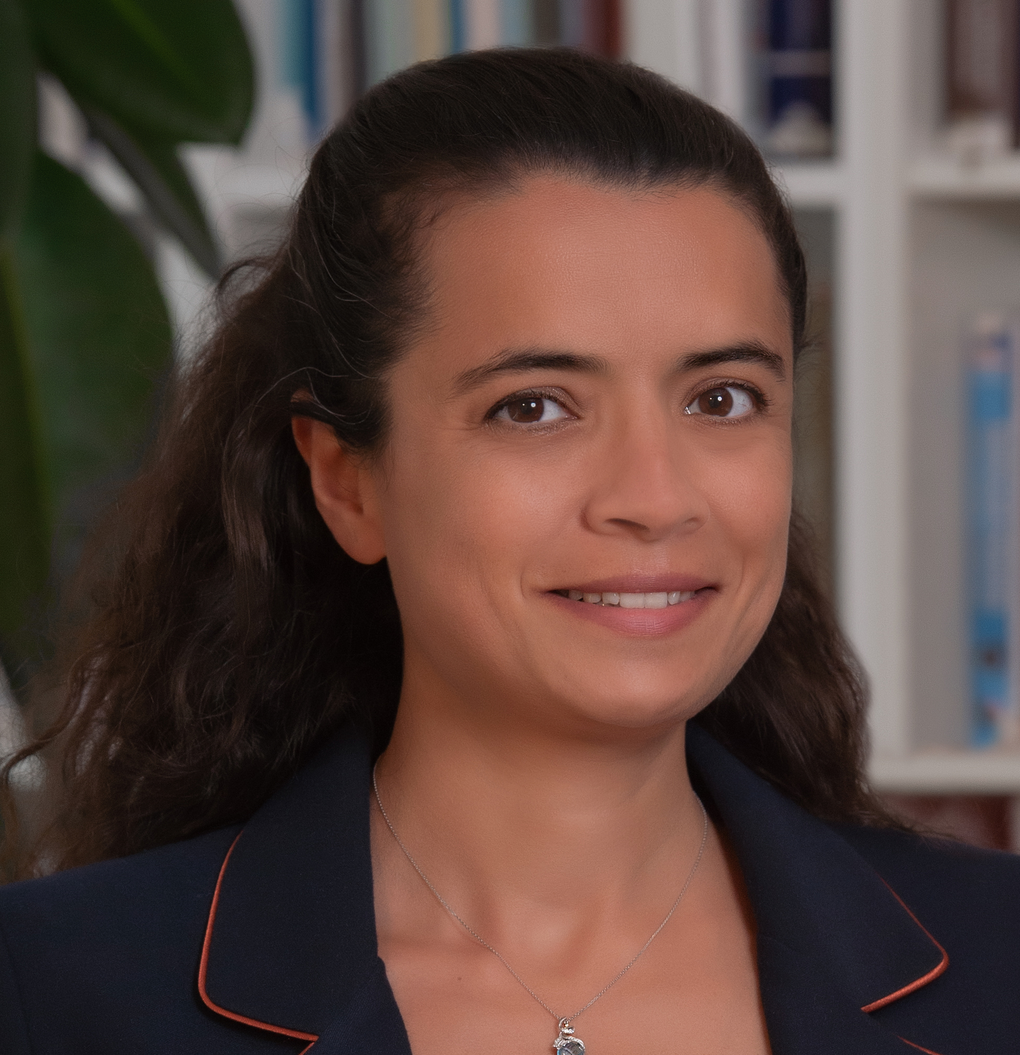
Özden Yüce Demir

Of Counsel

- Dealing with clients and listening to their concerns and assisting them in all aspect of their cases in civil, commercial and labour law.
- Assisting clients in preparing contracts and advising on contracts.

ozden.yuce@ycetinel.av.tr
+90 532 486 92 00

Nationality
Turkish

Languages
Turkish (Native), English, Spanish

Education
International Training Center of ILO, TURIN – International Trade Law Post Graduate Course

Istanbul Bilgi University Master of Laws (LL.M.)

Istanbul Bilgi University (B.A. in Law) International

Büyükdere Caddesi No: 201
Levent Loft, Kat: 9 Daire:139
34394 Şişli / İSTANBUL
T +90 212 246 47 69
F +90 212 246 79 60

- Litigation
- Mediation
- Negotiation
- Providing consulting services to companies, research of legislation, negotiating contractual provisions with consultants and suppliers and coordination external legal counsels.
- Providing legal advice and involvement in IP rights.

Publication
Published master thesis as a book “Topographies of Microelectronic Semiconductor in Intellectual Property Law” – On Iki Levha Publishing.
Complementary Activities
Participated in The Hague Academy International Private Law Program, Den Hague, The Netherlands during the period 7-25 July 2008.
Participated in 4th Annual Olympia Human Rights Programmed Migrants and Refugees help in Nafplion, Greece during the period 1-8 September 2003.
Vali Konağı Cad. Poyracık Sk.
Çamlıbel Apt. N.51 D.11/12
Nişantaşı - İSTANBUL
T +90 212 246 47 69
F +90 212 246 79 60
Vali Konağı Cad. Poyracık Sk.
Çamlıbel Apt. N.51 D.11/12
Nişantaşı - İSTANBUL
T +90 212 246 47 69
F +90 212 246 79 60

